|  |  |
| --- | --- |
|  | Department of Computer Science and Engineering Faculty of Engineering, University of Moratuwa  **CS 2033 – Data Communication and Networking**  B. Sc. Engineering Semester 3 |

Student Name ……………………………………………………..……………………………….. Field: **CSE**

Index No ………………………………...…….. Group ……….…… Date ………………………..

**Practical 3 : Basic Routing**

Note: Each student should individually submit this lab sheet to moodle.

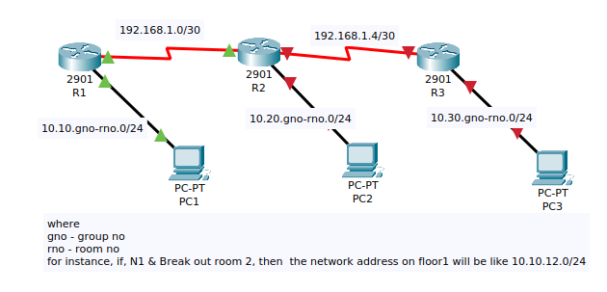

**10.30.wno.0/24**

**10.20.wno.0/24**

**10.10.wno.0/24**

**10.10.gno.0/24**

**wno = workstation number.**

**For example, for those who are working with the router at workstation 2 should use the network address 10.20.2.0/24**

1. Create the network as shown in the picture above.

Since this network requires three routers, please divide the whole class into two groups where one group will be working on three workstations and other group will be working on the other three workstations.

2. List interfaces (of routers and PCs) and IP addresses that you are planning to assign:

| Device | Interface | IP address |
| --- | --- | --- |
|  |  |  |
|  |  |  |
|  |  |  |
|  |  |  |
|  |  |  |
|  |  |  |
|  |  |  |
|  |  |  |

3. View the initial configuration of R1, State the command you used:

4. Assign IP addresses according to the above table. State the commands you used to assign IP addresses to the interfaces of R2.

5. Create IP Routes on R1, R2, and R3 to enable communications among PC1, PC2 and PC3. You can set static routes / default routes as necessary.

6. State the commands you used on R2 and R3 to set routes.

7. Ping from one PC to other two PCs (in the above diagram), observe and comment on the reachability.

8. Copy and paste a screenshot/photo of configuration of R1 and R2 here: